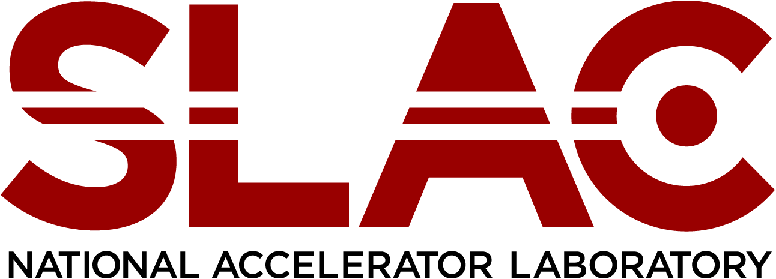

OFFICE OF HUMAN RESOURCES

The Alonzo W. Ashley Internship Program

The Alonzo W. Ashley Internship Program was named in honor of Al Ashley, who retired from SLAC in 1999 after 31 years of dedicated and exemplary service, particularly in the area of championing diversity in the sciences and engineering. During his tenure at SLAC, Al pioneered programs that promoted diversity and encouraged career development for employees, and career exploration for talented students. He was a recipient of a 2005 NSF Presidential Award for Excellence in Science, Mathematics and Engineering Mentoring in recognition of his outstanding mentoring efforts and programs that enhanced the participation of historically underrepresented groups in science, mathematics, and engineering. Al served as a mentor to hundreds of emerging scientists and engineers during their journey to their chosen field.

This program is designed to provide a year-long research/employment experience in each of our five major divisions. The program is intended for post-graduate candidates with the longer-term objective of potentially moving them into regular employment with the lab.

Program Overview
The Alonzo W. Ashley Internship Program provides five interns practical experience in mission critical fields with the expressed objective of bridging education and professional work experience for underrepresented groups. These one-year, limited term positions will provide the participant with valuable experience working at a DOE National Lab and exposure to world class science and operations.
Eligibility
Candidates must have completed their undergraduate, graduate or doctorate program
(depending on the identified position) and be a U.S. citizen or documented resident alien. Further, their career aspirations must lie within the scope of employment opportunities available at SLAC.

.

