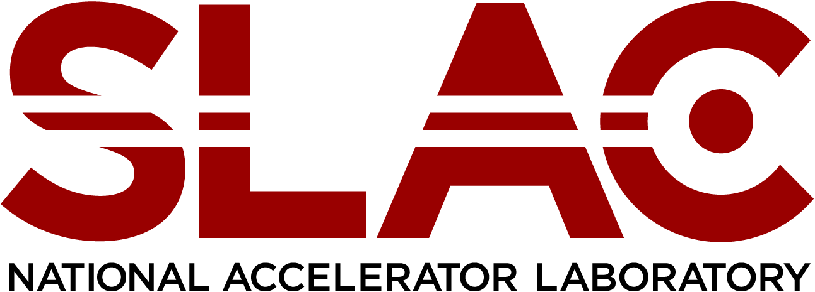

OFFICE OF Human Resources

**Job Title:** LCLS Area Physicist Assistant Intern

**Location:** Menlo Park, CA

**Full/Part Time:** Full-Time

**Regular/Temporary:** Fixed Term, benefit eligible

The Alonzo W. Ashley Internship Program was named in honor of Al Ashley, who retired from SLAC in 1999 after 31 years of dedicated and exemplary service, particularly in the area of championing diversity in the sciences and engineering. During his tenure at SLAC, Al pioneered programs that promoted diversity and encouraged career development for employees, and career exploration for talented students. He was a recipient of a 2005 NSF Presidential Award for Excellence in Science, Mathematics and Engineering Mentoring in recognition of his outstanding mentoring efforts and programs that enhanced the participation of historically underrepresented groups in science, mathematics, and engineering. Al served as a mentor to hundreds of emerging scientists and engineers during their journey to their chosen field.

This program is designed to provide a year-long research/employment experience in each of our five major divisions. The program is intended for post-graduate candidates with the longer-term objective of potentially moving them into regular employment with the lab.

**Program Overview**  
The Alonzo W. Ashley Internship Program provides five interns practical experience in mission critical fields with the expressed objective of bridging education and professional work experience for underrepresented groups. These one-year, limited term positions will provide the participant with valuable experience working at a DOE National Lab and exposure to world class science and operations.

**Eligibility**  
Candidates must have completed their undergraduate, graduate or doctorate program

(depending on the identified position) and be a U.S. citizen or documented resident alien. Further, their career aspirations must lie within the scope of employment opportunities available at SLAC.

**Responsibilities**

Assist LCLS Area Physicists in the Accelerator Directorate. Monitor and evaluate electron and x-ray beam conditions and factors affecting those conditions. Participate in the daily operation of the accelerator, which includes shift work (day, swing, occasional weekends). Interact with the operations staff of accelerator, photon, and experimental beam lines. Possess of develop skills necessary to independently assist accelerator operations. Develop new procedures and techniques as needed.

**Skills Required**

The LCLS Area Physicist Assistant Intern is designed to bridge educational achievement with professional work experience. We are seeking candidates who have recently completed their undergraduate program in engineering, physics, or a related field and are looking to apply their knowledge and skills to a one-year on the job¿ experience. Four year college degree in engineering, physics, or related field. Programming experience or class work is essential. Analytical and problem solving skills, attention to detail, and good organizational skills are essential. Optics experience or class a plus. Signal processing experience or class a plus. Statistics experience or class a plus. Some UNIX exposure a plus. Demonstrated ability to work within a group.

For consideration of candidacy for this one-year paid, benefited position, please submit your resume along with college transcripts indicating your GPA from your university, and two letters of recommendation to [mmastro@slac.stanford.edu](mailto:mmastro@slac.stanford.edu)