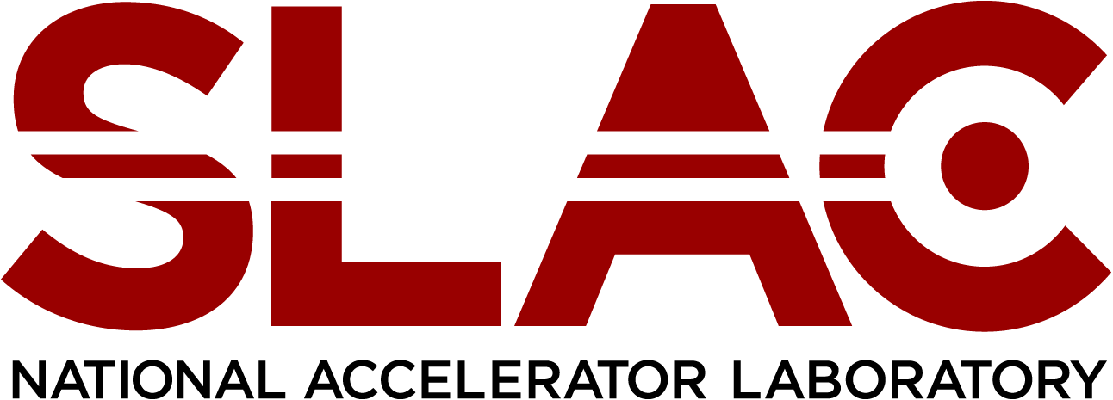

OFFICE OF Human Resources

**Job Title:** Operations Engineering Intern

**Location:** Menlo Park, CA

**Full/Part Time:** Full-Time

**Regular/Temporary:** Fixed Term, benefit eligible

The Alonzo W. Ashley Internship Program was named in honor of Al Ashley, who retired from SLAC in 1999 after 31 years of dedicated and exemplary service, particularly in the area of championing diversity in the sciences and engineering. During his tenure at SLAC, Al pioneered programs that promoted diversity and encouraged career development for employees, and career exploration for talented students. He was a recipient of a 2005 NSF Presidential Award for Excellence in Science, Mathematics and Engineering Mentoring in recognition of his outstanding mentoring efforts and programs that enhanced the participation of historically underrepresented groups in science, mathematics, and engineering. Al served as a mentor to hundreds of emerging scientists and engineers during their journey to their chosen field.

This program is designed to provide a year-long research/employment experience in each of our five major divisions. The program is intended for post-graduate candidates with the longer-term objective of potentially moving them into regular employment with the lab.

Program Overview  
The Alonzo W. Ashley Internship Program provides five interns practical experience in mission critical fields with the expressed objective of bridging education and professional work experience for underrepresented groups. These one-year, limited term positions will provide the participant with valuable experience working at a DOE National Lab and exposure to world class science and operations.

Eligibility  
Candidates must have completed their undergraduate, graduate or doctorate program

(depending on the identified position) and be a U.S. citizen or documented resident alien. Further, their career aspirations must lie within the scope of employment opportunities available at SLAC.

**Responsibilities**

* With support from the Project Manager, monitor project contractual commitments to assure that all work is performed in accordance with the design, specifications, drawings, and terms of the subcontracts. Support periodic project/ customer meetings and prepare the Project Status Reports. Support the preparation of progress and special reports to the customer and SLAC Lab management. Assist PM in the resolution of project, schedule, and priority issues.
* Assist the Project Manager in the review project forecasts, schedules, cost estimates, and financial reports.
* As new project are identified, with the support of the Project Manager, assist in the planning and development of the project scope, budget, execution plans, risk analyses and risk mitigation plans and overall project schedule. Assist in the establishment and control the budget for project costs. Assist the Project Manager, review major procurements, change orders, and subcontracts. Support the Project Manager to develop project scopes of work.
* With oversight from the Project Manager, ensure that Work Planning and Control is consistent with SLAC’s integrated safety management systems and that all work is conducted in accordance with SLAC’s ES&H policies and procedures.
* Support the Project Manager on Quality Assurance (QA) on how well specific project plans are implemented.
* Quality Assurance support of Primavera Contract Manager (PCM) to support review of DCR's consistently done, do they contain adequate detail, etc.
* Assist in the operation and maintenance of existing groundwater and vapor extraction systems, including performing daily and weekly inspections of the systems.
* Assist with the preparation for and performance of groundwater sampling as well as preparation of semi-annual reports. Activities may include procuring laboratory and sampling services, preparing sample bottle labels and chain-of-custody-forms, packing samples and sending them to the laboratories, checking and summarizing data, and preparing tables, figures and texts for the reports.
* Support preparation of environmental documents including feasibility studies, sampling work plans and reports, excavation reports, other miscellaneous reports.
* Support soil, sediment, or soil vapor sampling programs if/when they are required.
* Assist with pre-processing of analytical data including formatting data files, updating electronic records etc.
* Assist with environmental compliance programs in air, surface and industrial wastewater, waste treatment, or environmental sustainability initiatives.

**Skills Required**

A BS degree in civil, chemical, or environmental engineering, geology or related science field. Excellent oral and written communication skills required, as well as proficiency using the Microsoft Office Suite. Ability to work in a fast-paced, multi-tasking environment. Ability and willingness to maintain level of training required by DOE, SLAC, and outside agencies as required for the position.

For consideration of candidacy for this one-year paid, benefited position, please submit your resume along with college transcripts indicating your GPA from your university, and two letters of recommendation to [mmastro@slac.stanford.edu](mailto:mmastro@slac.stanford.edu).